Laboratory Project Report

BCS202: Introduction to Computing Science II

Menu-Driven Inventory Management System
Submission Date: 24th November 2025 Instructor: Mr. Adel Yousefi

Group Details
Name of Student | Student ID | Role/Contribution
Kholoud Elalfy | 20230002874 | Inventory Manager, Product, UML diagram, Report
Lana Aldeiri | 20240005390 | Main App, Perishable Product, Exception Handling, Testing

1. Problem Analysis & Solution Proposal

Problem Statement
  - Managing inventory manually can be inaccurate.
  - Difficulty monitoring items’ quantities, prices, and expiry dates.
  - Calculating stock updates without a system can be time consuming.

Proposed Solution & Objectives
  - Apply object oriented programming concepts like classes, inheritance, encapsulation, exception handling, and overriding.
  - Create a menu-driven system to add, view, update, delete, and search for products.
  - Organize and maintain product data efficiently using arrays.

1.3 Justification of Computing Principles
- Data Structure Choice: Explain why you chose an Array (or ArrayList) to store products. What are the pros/cons?
Why array?
  - Easy to access by index
  - Matches the project requirements
Pros:
  - Easy to use and understand
  - Works well when the number of products is limited
Cons:
  - Fixed size (can’t go above specific number of items: 50)
  - Deletion requires shifting elements manually

- OOP Approach: Why is Object-Oriented Programming (Inheritance/Encapsulation) better for this problem than procedural programming?
Procedural Programming:
  - In procedural programming, all data might be stored in arrays or other functions, increasing the risk of errors.
  - The data is not protected, which means that any new function can affect the data.
  - Every operation will require a separate function. (no inheritance)
OOP (Encapsulation/Inheritance):
  - Encapsulation protects the data and keeps them organized, making the code easier to maintain
  - Inheritance avoids code repetition and allows new product inputs easily.

2. System Design (Phase 1)

2.1 UML Class Diagram
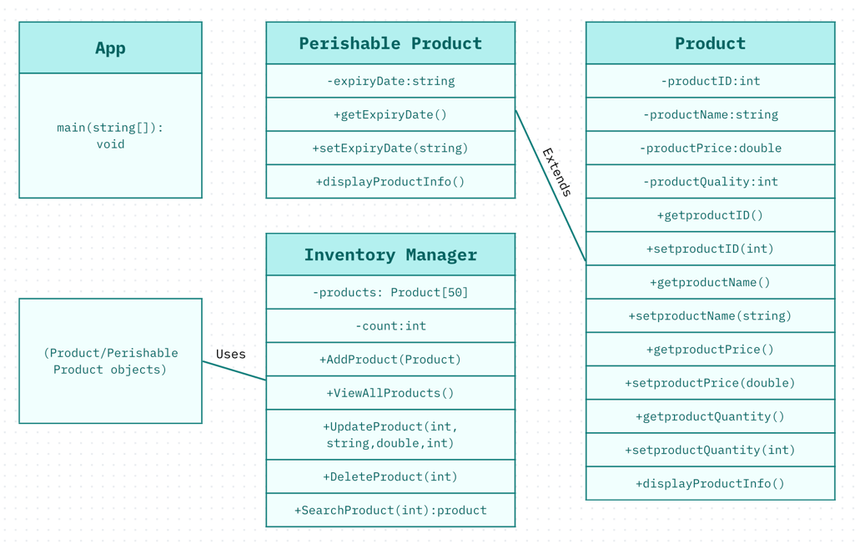

2.2 Class Descriptions
- Product Class: Defines a basic inventory item with private attributes: productID, productName, productPrice, and productQuantity. It uses getter and setter methods to manage these attributes and display the product information.
- PerishableProduct Class: An extension of the product class, so it receives all its attributes automatically. It adds its own field called expiryDate. It also overrides displayProductInfo() to show the expiry date with the product information.
- InventoryManager: This class handles an array of up to 50 Products. Its responsibility is to perform CRUD operations on that array.
- AddProduct(): inserts a new product into the array.
- ViewAllProducts(): loops through the list and display each product.
- UpdateProduct(): finds a product by its ID and updates its attributes (name, price, quantity).
- DeleteProduct(): removes a product and shifts the remaining items in the array to keep it organized.
- SearchProduct(): looks for a product by its ID and returns it when it's found.

3. Core Implementation & OOP Adherence

3.1 Object-Oriented Principles Applied
Provide a small code snippet and explanation for each:
- Encapsulation: (e.g., Show private fields and getters/setters).
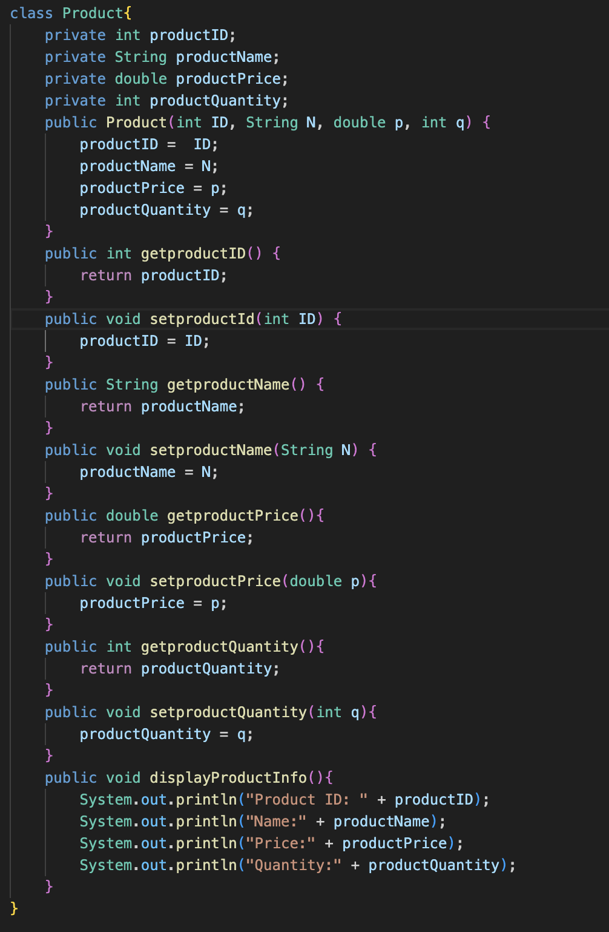

Encapsulation means keeping data private and allowing access through public getters and setters. Fields like productid and productName can’t be accessed directly.

- Inheritance: (e.g., Show class PerishableProduct extends Product).

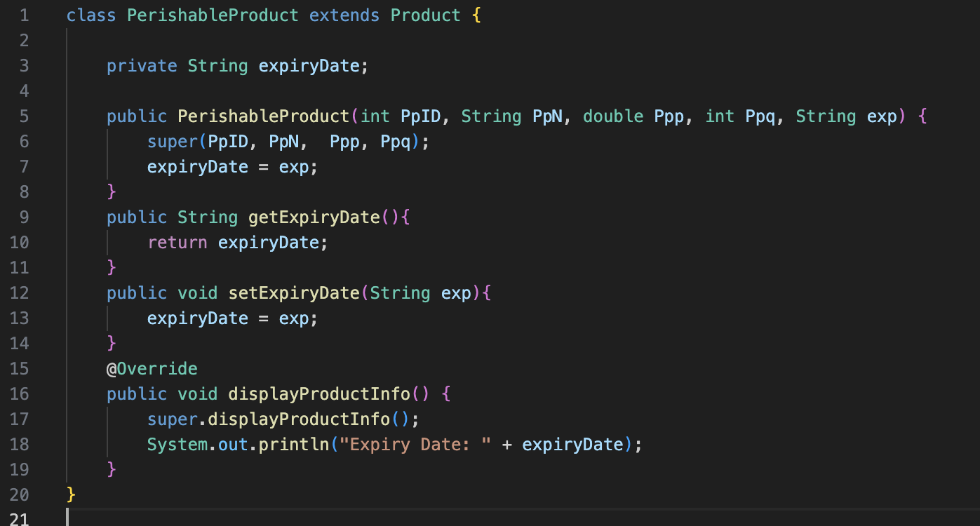
Inheritance allows a class to extend and reuse another class instead of rewriting it all over again. PerishableProduct class inherits all fields and methods of Product class and adds it's own attribute (expiryDate).

- Polymorphism/Overriding: (e.g., Show the @Override displayProductInfo() method).


Polymorphism allows a subclass to extend a method from it's parent class. PerishableProduct overrides displayProductInfo() so it prints everything from Product class in addition to the expiry date. This means that both Product and PerishableProduct classes use the same method name, but each show different information.

Exception Handling Strategy
- Custom Exceptions:
  - ProductNotFoundException: Triggered when the system is trying to search for or delete a product using a nonexistent ID. The program throws this exception to inform the user that the product can’t be found instead of returning a null.
  - InvalidInputException: Triggered when the user enters an invalid input, like leaving the field empty or entering a string when the system expects an integer, by giving the user a clear error message. This exception prevents incorrect data from being added to the inventory.
- Robustness: How does the system handle a user entering "ABC" instead of a price? (Show the try-catch block screenshot).
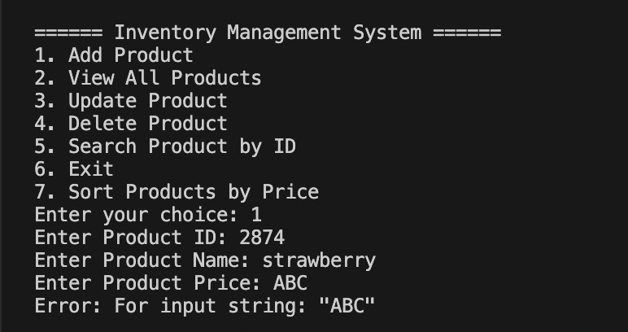

4. Advanced Features & Logic (Phase 2 & 3)

4.1 Search & Sort Algorithms

Explain the logic used to find a product by ID.
Searching algorithm: The logic used to find a product by ID in the InventoryManager class is linear search. SearchProduct(int id) checks each product in the array one by one and compares the productID with the ID being searched. If it matches, the product’s name will be printed. If it doesn’t match, it moves to the next product and repeats the process until the end of the array. If no product is found after checking all products, the method throws a ProductNotFoundException. This exception stops the flow of the program and shows an error message to the user.
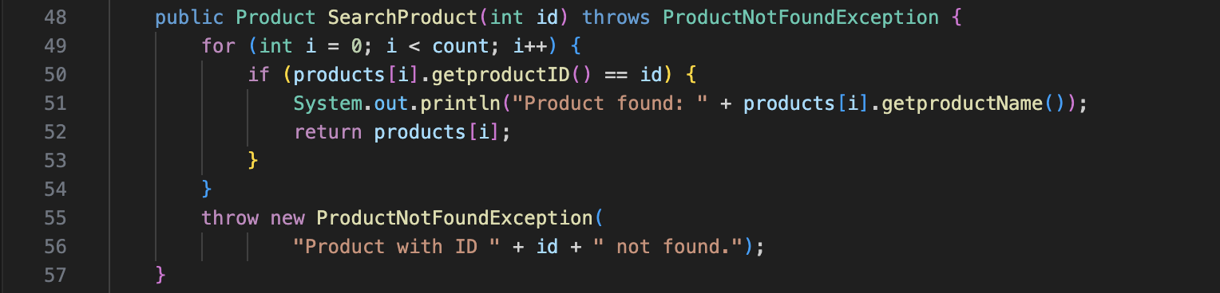

4.2 Advanced Features (Extensions)
Describe any extra features added (e.g., File I/O, GUI, or complex calculation logic).
An additional extension used is sorting algorithm (bubble sorting), which sorts the products based on their prices (from least to greatest). This helps users access the products list faster and more organized.
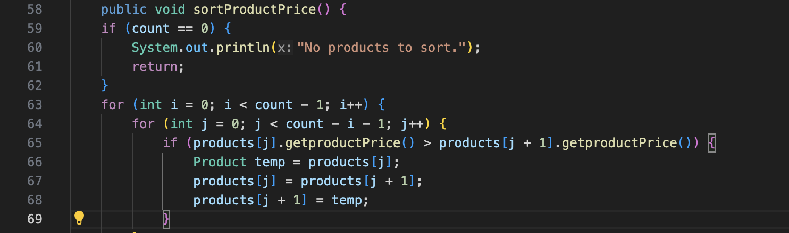

5. Testing & Validation (Phase 3)

5.1 Test Cases
Test Case | Input | Expected Output | Actual Output | Result
Add product | ID = 5390  Name = grapes  Price = 6.00  Quantity = 4  Perishable? = n | “Product added successfully!” | “Product added successfully!” | Pass
Add perishable product | ID = 2874  Name = strawberries  Price = 4.00  Quantity = 12  Perishable? = y  Expiry Date = 12-12-2025 | “Product added successfully!” | “Product added successfully!” | Pass
Search non-existing product | ID = 6283 | “Error: Product with ID 6283 not found.” | “Error: Product with ID 6283 not found.” | Pass
Update product | ID = 2874  New name = watermelon  New price = 6.00  New quantity = 4 | “Product updated successfully!” | “Product updated successfully!” | Pass
Delete product | ID = 2874 | “Product deleted successfully!” | “Product deleted successfully!” | Pass
Delete non-exisiting product | ID = 5679 | “Error: Cannot delete — product with ID 5679 not found.” | “Error: Cannot delete — product with ID 5679 not found.” | Pass
Search product | ID = 5390 | “Product found: grapes” | “Product found: grapes” | Pass

5.2 Execution Screenshots
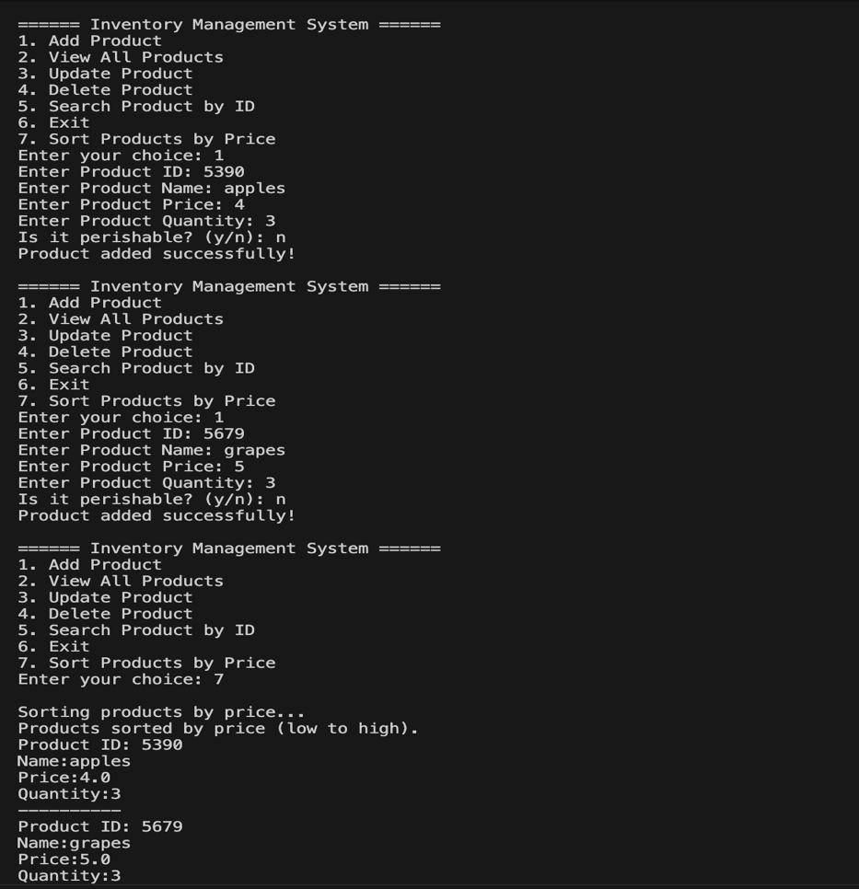
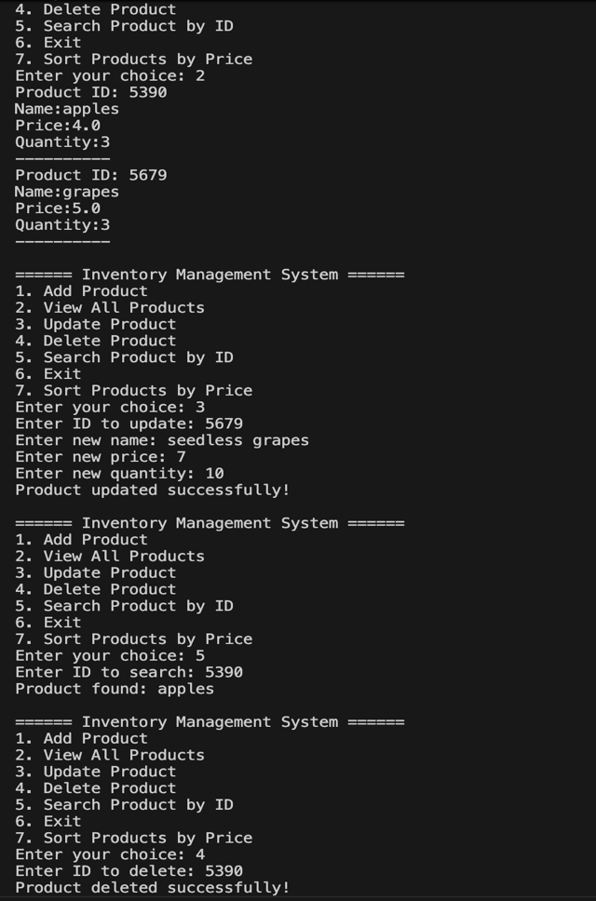

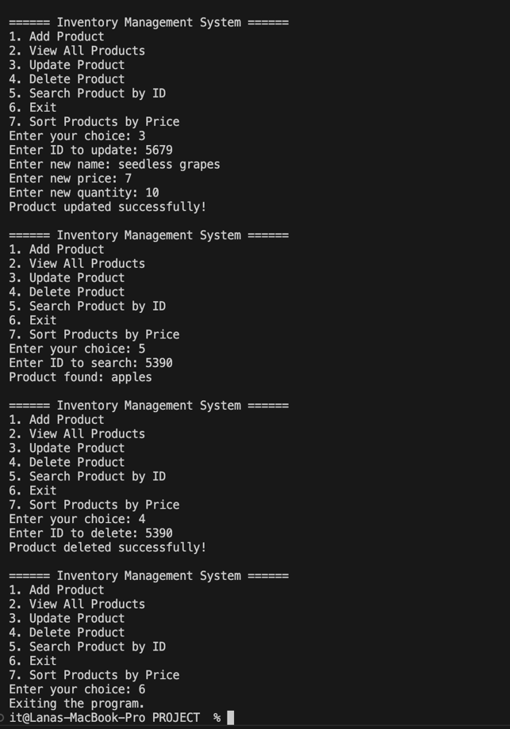

6. Conclusion & GitHub Repository
- Summary: Brief wrap-up of what was achieved.

This project achieved an Inventory Management System using OOP, which allows users to add, view, search, and delete products and perishable products. Advanced features like exceptions, searching, and sorting help make the system more reliable and improve the user experience. By using methods such as encapsulation, inheritance, and polymorphism (overriding), the program stays organized and easy to use and expand.
- GitHub Link: [Insert URL to your repository here]
https://github.com/lasaldeiri/InventoryManagementProjectFINAL

